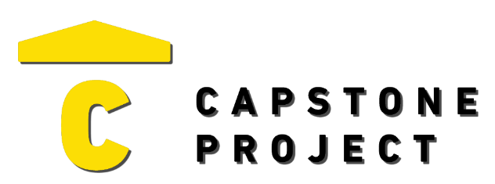
USER FEEDBACK
User Name: Kenneth Hannigan
What are your thoughts on the project overall?
Pretty cool capstone project. The dark theme looked really good and professional. Didn’t run into any bugs.

Was the project enjoyable? What was your favorite part of the project?
Yeah, I liked messing around the dev tools and triggering the sensors. The event log was a neat touch.
What changes would improve the project?
It would be nice to edit or update a device after adding it, like changing the location.

Capstone Project Ratings:
Project Technology Depth (shows good usage of technology) | High
Project Breadth (number of features and content) | High
Professional Presentation (analogous to a real-world product) | High
Implementation Quality (number of bugs and errors) | High
Project Completeness (project contains essential functionality) | High

Game / Application / Website Ratings:
Visuals (art style, environment, effects) | Very Positive
Audio (sound effects, music) | Not Applicable
UI (title, menus, UI elements, text) | Very Positive
Controls (intuitive, ease of use, ease of navigation) | Positive
Interactivity (fun, engagement, flow) | Very Positive

